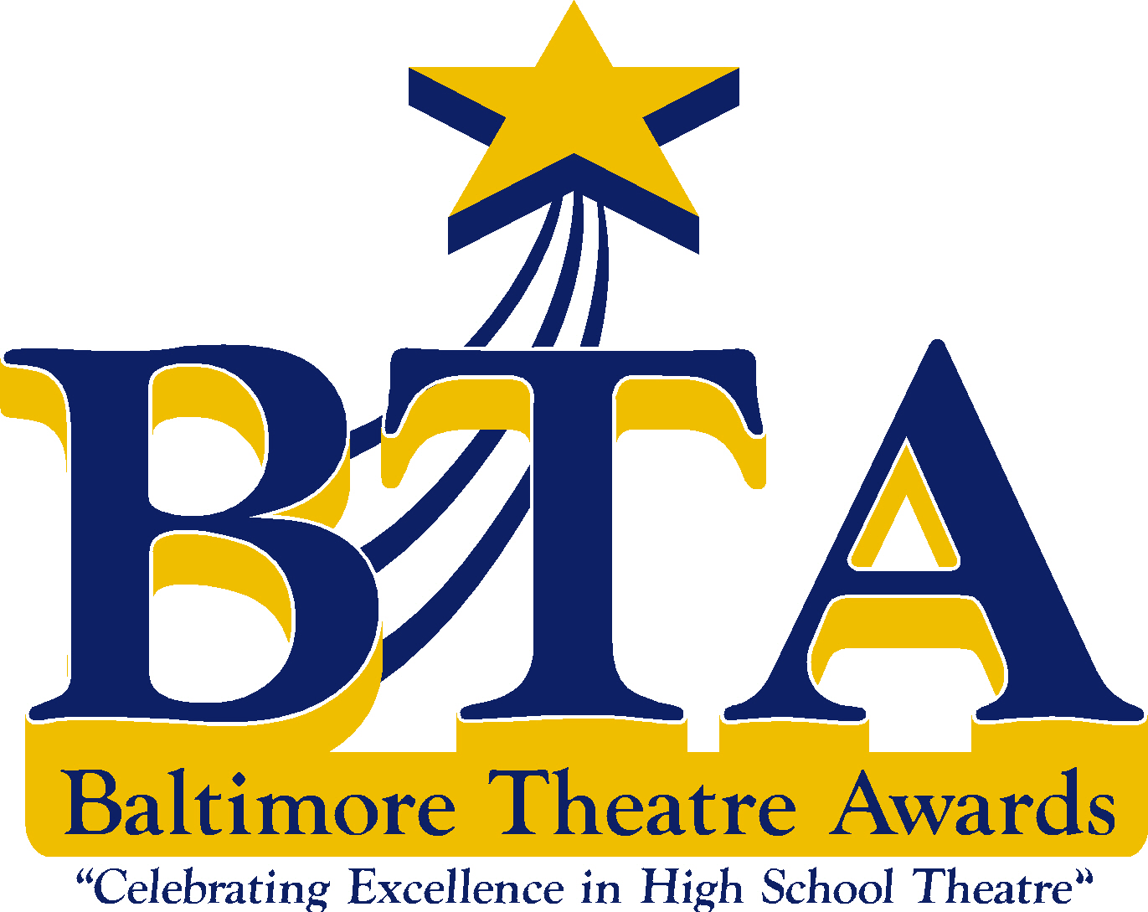

2015- 2016 Registration Form

School Name :

School Contact Name :

School Contact Email:

School Contact Telephone :

Show Title :

Show Dates and Times:

Address where performances will be held (Please include Zip Code)

Please email this form back to baltimoretheatreawards@gmail.com

Please send check via regular mail to:
Baltimore Theatre Awards
C/o Laura Miller
Beth Tfiloh High School
Creative Arts Department
3300 Old Court Road
Baltimore, MD 21208

CHECKS MADE OUT TO: Baltimore Theatre Awards

